Introduction
Tobacco smoking is one of the leading causes of death in Australia. According to the Australian Bureau of Statistics (ABS) (2015), smoking has killed an estimated 19,000 Australians per year. It is associated with risks such as respiratory conditions, eye diseases and other health conditions. Since 1973, the government has worked to implement a range of policies to reduce smoking rates, including taxing tobacco products, prohibiting smoking in selected locations and restricting smoking advertisements.
Tobacco smoking is regarded as an epidemic in Australia and other parts of the world. Regardless of the measures that have been taken by the Australian government to regulate the use of tobacco, people are still dying from tobacco use. Tobacco affects not only smokers but also people around them through a process called passive smoking (Hill & Carroll 2003). To reduce externalities, such as loss of lives, the government continues to implement more control measures.
Australian government and health groups’ multi-pronged strategy
Below are the measures that have been taken by the Australian government since 1990 to reduce tobacco intake:
1993 Implementation of the Advertising Prohibition Act
1994 Ban on smoking in public places
1997 Implementation of the National Tobacco Campaign
2006 Introduction of graphic warnings on tobacco packaging products
2010 An increase of 25% excise duty on tobacco
2012 A directive of explained health warnings on a plain tobacco package
2013–2017 Another increase in tobacco excise by 12.5%
2018–2020 Additional increase in excise every year

According to the ABS 2017–18 (ABS, 2018), about 2.6 million adults smoke daily. The number of adult smokers increased from approximately 49% in 2007 to 52% in 2015, and then, up to approximately 55% in 2018. According to the National Health Survey 2017–2018, the rates of smokers, for both men and women, have declined since 1995: approximately 20% of women and 27% of men smoke daily. According to the ABS (2015), the tobacco control measures have been effective, leading to a decrease in the number of daily smokers aged 18 years and above since 2001, as per the below table.
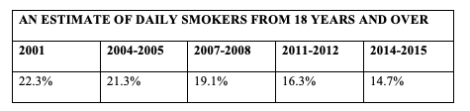
The Australian government established four significant objectives to increase the effectiveness of reducing tobacco consumption. The objectives are as follows: health information awareness, regulations such as taxation, support for free smoking zones and building of coalitions for tobacco control (Hill & Carroll 2003). Furthermore, some of these strategies have had substantial effects on reducing consumption, while others had no significant effect. However, the government continues to implement more measures and improve current strategies to achieve the same goal. According to the National Drug Strategy 2016 (Ministerial Council on Drug Strategy 2011), below were the findings of a survey:
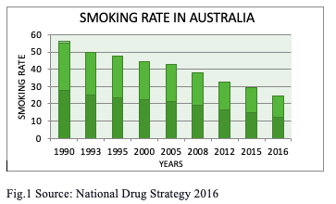
In 2004–2009, the Australian government developed the National Tobacco Strategy to reduce the demand for tobacco (Wakefield, Freeman & Donovan 2003). The policy focused on reducing health complications and other harms caused by smoking tobacco. The policy promoted messages and texts that explained the harmful effects of tobacco, and it also advocated a smoke-free zone policy.
The essential steps developed by the government were as follows: first, reduce health complications and other harm caused by smoking tobacco, through decreased exposure. Second, promote messages that advocate quitting smoking, and which support smoke-free zones. In addition, improve the health facilities for treating smokers (Ministerial Council on Drug Strategy 2004). Moreover, advocate social distancing that was highly associated with smoking behaviour, and support healthy lifestyles through seminars and educational campaigns. Furthermore, establish accessible messages and services on reducing tobacco consumption (Scollo et al. 2003). Lastly, develop research to evaluate more effective ways to reduce tobacco intake.
As much as the policy seemed effective, the government realised the need to implement a new approach to achieve the same goal. According to White et al. (2003), tobacco consumption is growing to become one of the most common health complication factors. As a result, a National Drug Strategy 2010–2015 was developed to reduce harm to consumers and their surrounding communities (Ministerial Council on Drug Strategy 2011). The strategy was categorised into three pillars: reduce harm, reduce supply and reduce demand.

Impact of the strategies on the consumption of tobacco
The National Tobacco Strategy 2004–2009 had a positive impact on consumers and different socioeconomic groups (Ministerial Council on Drug Strategy 2004). The strategy’s effectiveness can be measured by the reduction in the number of second-hand smoking cases, which was achieved by decreasing non-smokers’ exposure risk (White et al. 2003). Also, as a result, the rate of teenage smoking decreased as well.
In 2007, a research project concluded that the number of family members that smoked tobacco had decreased (Lin et al. 2007). In addition, mass media campaigns were used to remind the public about the harmful impact of tobacco continuously. This strategy was one of the most effective in achieving the objective of taking control of the state, especially banning smoking advertisements and enforcing a ban on selling tobacco to minors (Wakefield, Miller & Roberts 1999).
In 2004, the Australian government made a directive for graphic health warnings on imported tobacco products. A policy was also formed for suppliers and manufacturers to include the quantitative measurements of the ingredients (carbon monoxide, nicotine and tar) on the packaging covers of tobacco products. Apart from the legislation initiated by the Australian government, a tax was also imposed on tobacco product sales to reduce tobacco consumption and demand (Scollo et al. 2003). As a result, the prices of tobacco products increased, and the demand for them decreased, especially among the young and the poor communities (Hu et al. 2016).
The operation of an excise tax on tobacco product sales
A tariff refers to the imposition of a tax on the manufacturers and suppliers of products in Australia to reduce the consumption or importation of a good. The imposition of taxes on tobacco products is meant to discourage consumers from consuming tobacco in order to protect them from health complications (Scollo et al. 2003). Below is an illustration of the effect of excise duty on tobacco:

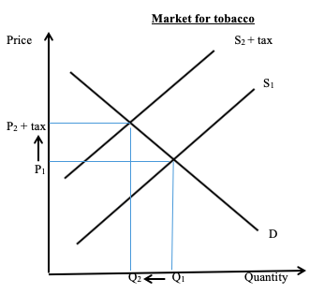

From the diagram, it can be seen that when tax is imposed on the manufacturer, the producer transfers the burden of tax to the consumers. The manufacturer is required to pay this tax to the government. Therefore, the cost of supplying the product into the market increases as a result of the increased cost of production. The imposed tax to the manufacturer then raises the price on the customers for tobacco products from P₁ to P₂. In most cases, tobacco is addictive, and the tax may not have much effect on its consumption. Most consumers will continue to use the same quantity of tobacco, even with the increased price.
The price to the consumers increases due to the shift of the tax burden by the manufacturers, and the quantity reduces from Q₁ to Q₂. As a result, the introduction of the tax is effective in reducing tobacco consumption. However, in cases where the demand is required to be reduced, even more, the tax imposed is increased. A tax reduces the consumption of tobacco, including all the health diseases involved with tobacco intake, such as cancer. However, this results in the unemployment of tobacco farmers, since some farmers depend entirely on the tobacco business (Scollo et al. 2003).
Price elasticity measures the response of a product to price changes. When demand is elastic, a small increase in the price of tobacco products causes a big reduction in demand (Hu et al. 2016). By imposing a tax on the price of tobacco products, the price increases and the quantity demanded decreases. With the imposition of tax on prices, the supply of the tobacco products shifts to the left from S₁ to S₂ (with tax).

Anti-smoking education campaigns
Market failure occurs in a free market where the equilibrium output is less or greater than the optimal output (Wakefield, Freeman & Donovan 2003). As a result, the market will produce less or more goods, causing market failure. Below is a diagram to illustrate this in the tobacco market:

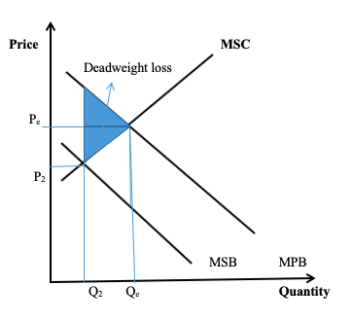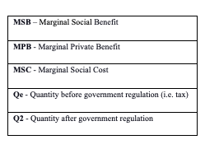
Since the aim of the anti-smoking education campaigns is to reduce consumption, but not eliminate tobacco smoking, the socially optimal level of tobacco consumption will be at Q₂, where the MSB = MSC, especially since there are no external costs imposed on the consumers. The consumer has a greater incentive to consume at Q_{e} , rather than at Q₂, because they enjoy greater marginal benefits compared to the marginal costs (MSB > MSC). This leads to an economic problem in the market. When there is no government intervention through regulation, the market resources will be over-allocated towards tobacco, leading to a deadweight loss (Hu et al. 2016). The over-allocation of resources can only be corrected by imposing a tax on tobacco product sales.
The impact of anti-smoking education campaigns in addressing the potential market failure in tobacco intake has generally reduced the demand and the consumption of the product, especially among youths (Wakefield, Miller & Roberts 1999). According to a report by Surgeon General on the prevention of the use of tobacco by youths and adults, it was concluded that smoking tobacco influences the occurrence of negative thoughts; hence, the anti-smoking advertisements are used to reduce the intake of tobacco among youths. These advertisements are more effective for young people.
The anti-smoking education campaigns are spread through television, radio and social media (Facebook, Twitter and Instagram). They have greatly influenced youths and teenagers by increasing awareness of the harmful effects of tobacco. A well-designed and comprehensive anti-smoking education campaign program should contain messages that advocate for a healthy lifestyle. The anti-smoking education campaigns have contributed to a reduction in the consumption of tobacco, especially among youths and teenagers, but it has not had much influence on adults (Wakefield, Miller & Roberts 1999).
When the price of tobacco increases, adults will still consume the product because they would be willing to sacrifice basic needs to buy tobacco (Scollo et al. 2003). Furthermore, the anti-smoking advertisements are not as effective compared to the advertisements for smoking. The advertisements to support smoking are widespread, unlike anti-smoking advertisements. For example, most movies present the act of smoking to be a stimulating action; therefore, most teenagers become excited to try it.

Reference List
Australian Bureau of Statistics [ABS] 2015, National health survey: First results, 2014–15, cat. no. 4364.0. 55.001.
Australian Bureau of Statistics [ABS], National Health Survey: First results, 2017–18, cat. no. 4364.0. 55.001.
Hill, D. & Carroll, T. 2003, ‘Australia’s national tobacco campaign’, Tobacco Control, vol. 12, suppl. 2, pp. ii9–ii14.
Hu, T. W., Mao, Z., Shi, J. & Chen, W. 2016, ‘The role of taxation in tobacco control and its potential economic impact in China’, in T. W. Hu (ed.), Economics of Tobacco Control in China: From Policy Research to Practice, World Scientific, New Jersey, pp. 149–168.
Lin, H. H., Ezzati, M. & Murray, M. 2007, ‘Tobacco smoke, indoor air pollution and tuberculosis: A systematic review and meta-analysis’, PLoS Medicine, vol. 4, no.1.
Ministerial Council on Drug Strategy 2004, National Tobacco Strategy, 2004–2009: The strategy, Ministerial Council on Drug Strategy, Australia.
Ministerial Council on Drug Strategy 2011, The National Drug Strategy 2010-2015: A framework for action on alcohol, tobacco, and other drugs, Ministerial Council on Drug Strategy, Australia.
Scollo, M., Younie, S., Wakefield, M., Freeman, J. & Icasiano, F. 2003, ‘Impact of tobacco tax reforms on tobacco prices and tobacco use in Australia’, Tobacco Control, vol. 12, suppl. 2, pp. ii59–ii66.
Tan, N. & Hassard, K. 2000, ‘Quitline calls and campaign television investment’, in Australia’s National Tobacco Campaign: Evaluation Report Volume Two, Department of Health and Aged Care, Canberra, pp. 133–138.
Wakefield, M., Freeman, J. & Donovan, R. 2003, ‘Recall and response of smokers and recent quitters to the Australian National Tobacco Campaign’, Tobacco Control, vol. 12, suppl. 2, pp. ii15–ii22.
Wakefield, M., Miller, C. & Roberts, L. 1999, ‘Comparison of the National Tobacco Campaign with a youth-targeted South Australian campaign’, in Australia’s National Tobacco Campaign: Evaluation Report Volume One, Commonwealth Department of Health and Aged Care, Canberra.
White, V., Tan, N., Wakefield, M. & Hill, D. 2003, ‘Do adult focused anti-smoking campaigns have an impact on adolescents? The case of the Australian National Tobacco Campaign’, Tobacco Control, vol. 12, suppl. 2, pp. ii23–ii29.

